Open below link and click on consumer.
https://www.npci.org.in
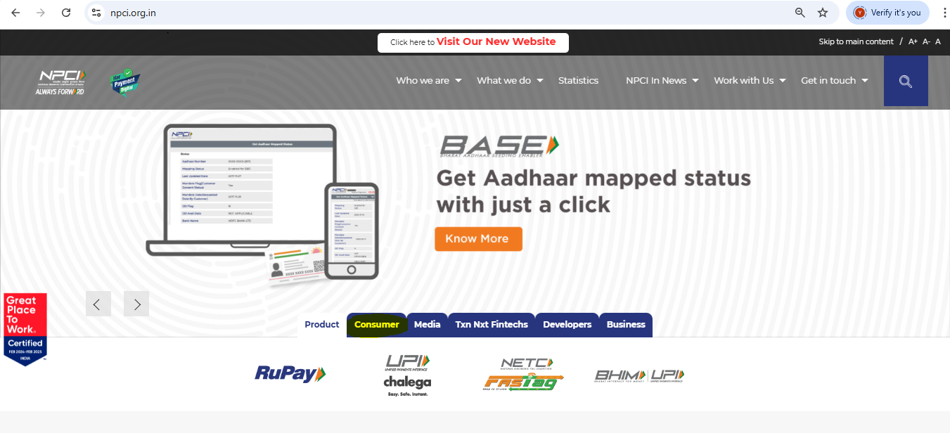
Click on Bharat Aadhaar Seeding Enabler (BASE)

For Aadhar seeding click on Aadhar seeding/Deseeding.
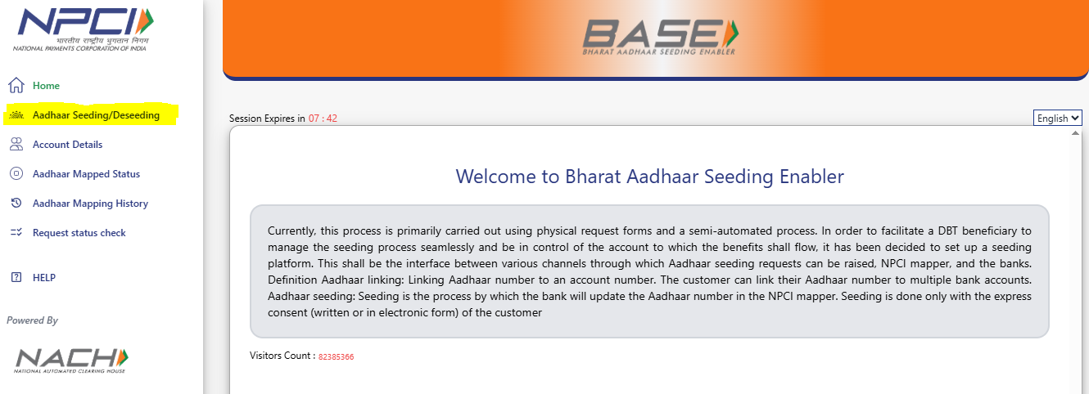
Enter the required data in below highlighted fields and click on submit
